

CSE Fall 2015 Semester Final

Please use answer key. Do not write on test.

1. Perform the following calculation in binary

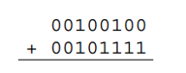

1. 01010011 c. 01100011
2. 01001101 d. 01101010
3. How many bits are in a byte?
4. 2 c. 8
5. 16 d. 32
6. Convert the binary number to decimal

0 1 0 0 1 1 0 1

1. 66 c. 42
2. 77 d. 128
3. What is the number of bits needed in order to represent the number 7 in binary?
   1. 3 c. 4
   2. 7 d. 8
4. How many steps does the sprite take each time the green flag is clicked?

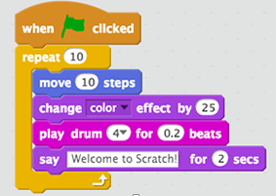

* 1. 10 c. 25
  2. 100 d. 1000

1. What will the code print?

print type(123)

* 1. <type ‘str’> c. <type ‘int’>
  2. <type ‘float’> d. <type ‘unicode’>

Matching (answers below):

1. ___ Event Handler
2. ___ Algorithm
3. ___ Sprint Task List
4. ___ State Diagram
5. ___ Code
   1. Data that describes everything about how a program exists at a given time.
   2. A list of small specific tasks to be completed in a set period of time.
   3. A piece of code that responds to an event.
   4. Instructions in a program.
   5. A step-by-step procedure, like a recipe.
6. What will the code print?

x = ‘Go’

y = ‘Hornets’

z = 2014

print x+y+z

1. Go Hornets
2. Go Hornets 2014
3. 2014
4. Error- cannot concatenate ‘str’ and ‘int’ objects
5. What will the code print?

x=True

y= False

z= False

if x or y:

print “yes”

else:

print “no”

1. yes c. False
2. no d. True

True or False:

1. ___Python is named after the snake
2. ___Turing Test - a measure of artificial intelligence where a human tries to discern if

the intelligence at the other end is either a human or computer.

1. ___Waterfall Design - A method of software development that emphasizes completing each stage of the design process before beginning the next stage.
2. ___Compression – Storing information in an expanded file state.
3. ___Tuple – A Python data type that can store a collection but cannot assign new

values.

1. What will the code print?

In[ ]: range(5)

a.Out[ ]: [1,2,3,4,5] c. Out[ ]: [1,2,3,4,5,6]

b.Out[ ]: [0,1,2,3,4] d. Out[ ]: [0,1,2,3,4,5]

More matching:

1. __Loops
2. __Conditions
3. __Statement
4. __Boolean expression
5. __Source program
6. __Machine language
   1. A command that instructs the computer to do something.
   2. A set of primitive instructions built into every computer. The instructions are in binary code.
   3. A program written in a language other than machine code, typically a high-level language.
   4. When a program only does something under certain circumstances.
   5. When a program does something multiple times.
   6. An expression that is either true or false.
7. What will the code print?

In[ ]: range(20, 30, 2)

* + - * 1. Out[ ]: [20, 22, 24, 26, 28, 30, 32]
        2. Out[ ]: [20, 22, 24, 26, 28, 30]
        3. Out[ ]: [20, 22, 24, 26, 28]
        4. Out[ ]: [20, 30, 40, 60]

1. What will be the output?

In[ ]: for x in range (2,5):

print x+2

1. 4 b. 2 c. 3

5 3 4

6 4 5

7 5 6

1. What will be the output?

In[ ]: x=12

In[ ]: y=18

In[ ]: x=y

In[ ]: print(x,y)

a.(12, 18) c. (x,x)

b.(18, 18) d. (x,y)

1. What will be the output?

In[ ]: x=1

In[ ]: y=2

In[ ]: x,y=y,y

In[ ]: print(x+y)

a. 4 c. 3

b. 2 d. 1

1. How many steps will the sprite take when the flag is clicked?

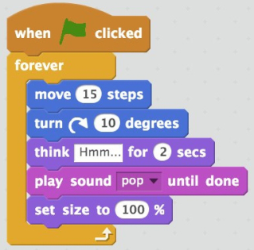

a.15 c. 10

b.150 d. infinite

1. What will be the output?

In[ ]: x=’abcd’

In[ ]: y=’2’

In[ ]: print(x+y)

a.Out[ ]: 2 c. Out [ ]:abcd2

b.Out[ ]: abcd 2 d. Out [ ]: error

1. What will the code print?

x=True

y= False

z= False

if x and y:

print “yes”

else:

print “no”

a) yes c. False

b) no d. True

1. Consider the following grading “program” given in pseudocode.

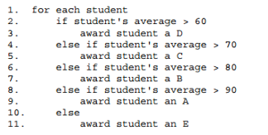

1. This code will result in the majority of the students awarded a “C”
2. None of the students ever will get an “A”, “B”, or “C”.
3. This code will result in the majority of the students awarded an “A”
4. There does not appear to be anything wrong with this code.
5. Why is this strip funny (to some people?) On your answer sheet explain in a few sentences how binary numbers work by explaining why 100 does, in fact, represent the value we know as four. 